NH Department of Agriculture, Markets & Food
Division of Regulatory Services

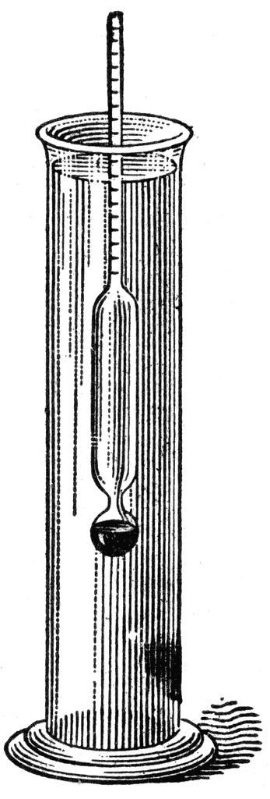

No Syrup Hydrometer clinics in 2021

Due to restrictions associated with COVID-19, the Department will not be able to offer public hydrometer clinics this year. Fortunately, we can offer the following alternative options.
- Contact an agricultural inspector to schedule a visit to your sugarhouse. While the agricultural inspector is at your sugarhouse, they are able to grade your syrup as well if you choose.
- For producers who participate in the department’s Seal of Quality program, we can test your hydrometer during your annual maple inspection.
- If a small group of producers want to arrange a day to meet or arrange to drop their hydrometers off at one sugarhouse, the inspector can then test several hydrometers at that location.

CDC guidelines will be followed during the on-site visit such as wearing a mask, social distancing, and practicing good hand hygiene. When you contact the ag inspector, they will discuss the details of the visit.

If you are interested in having your syrup hydrometer tested, and/or a maple inspection, please contact an agricultural inspector.

Janis Conner Janis.L.Conner@agr.nh.gov or 271-2753
Carroll County, Strafford County, and portions of: Merrimack, Rockingham, Belknap, & Coos

Alice Tuson Alice.C.Tuson@agr.nh.gov or 271-3509
Sullivan County, Grafton County, and portions of: Merrimack, Belknap, & Coos

Shane Conlin Shane.P.Conlin@agr.nh.gov or 271-3547
Rockingham, Hillsborough and Cheshire County

We appreciate your cooperation as we strive to provide safe alternatives to the annual clinics. Should you have any questions or concerns, please contact Jennifer, Director of Division of Regulatory Services, at Jennifer.Z.Gornnert@agr.nh.gov.

