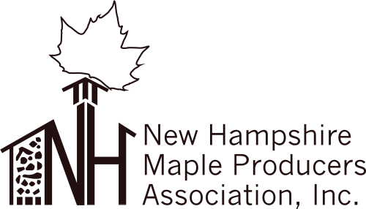

NH Maple Producers Assn Inc
Board of Director Meeting
January 25, 2020
Common Man, Plymouth NH

In Attendance: David Kemp, Bill Cheney, Sue Folsom, Darrell Fisk
Absent: Chris Olsen, Win van Mourik
Guest: Nick Kosko

Meeting called to order 2:36pm

Discussion was held regarding whether to hold Regional Meetings or not. The group decided they should be help. Sue will contact Patrick Connor at Intervale and Stuart and Johns for availability. Nick agreed to contact Remick Museum and Lancaster will be scheduled by someone reaching out to Dave Fuller.

The topic of lack of interest from the membership to volunteer to the Board was talked about with comments that there were a couple people willing to serve as help on committees but there were no immediate candidates for any of the Board vacancies. Due to the nature of the work required of the President and Vice President a motion was made by Bill Cheney to keep the positions open until qualified candidates could be found. Seconded by Darrell Fisk. The motion passed unanimously.

Nick spoke about his commitment to not leave the NHMPA Board without help from him to transition a new Vice President or President is found. He’s still very dedicated to the Association and will help any way he can. A motion was made by Dave Kemp for the Board to approve Nick as “Advisor to the Board” to facilitate transition with current and future Board members. It was seconded by Darrell Fisk and approved unanimously.

Meeting Adjourned 2:57pm

Respectfully submitted:
Sue Folsom
NHMPA Treasurer

